**PROJECT DESIGN PHASE-II**

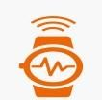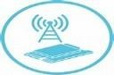

Microcontroller

Hand Band

Battery

LoRa

Button

GPS

|  |  |
| --- | --- |
| Team ID | PT2022TMID18845 |
| Project Name | IOT BASED SAFETY GADGET FOR CHILD MONITORING AND NOTIFICATION |
| Maximum Marks | 4 Marks |

**TECHNOLOGY STACK ARCHITECTURE**

The device can be activated by just pressing the trigger button in an emergency. The method which works behind this is as explained below:

* In fig.1 smart Hand Band consists of a GPS module, that is activated by retrieving its location based on its latitude and longitude. Then that location is fed to Microcontroller, which sends that data to our CubeSat through the LoRa transceiver.
* In fig.2 CubeSat includes a LoRa transceiver to receive the data from the Hand band and then data will be sent to the base station via Microcontroller and LoRa transceiver.
* In fig.3 The base station has the hardware of the LoRa receiver to receive the data from the CubeSat and has a GSM module to call and send an SMS to the police department and also the user’s parents. The SMS consists of a live location and a “Help Me” text.

Fig.1 Hand Band working process

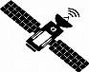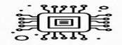

CubeSat

LoRa

LoRa

Microcontroller

Battery

CubeSat working process

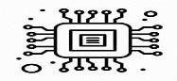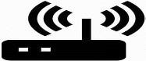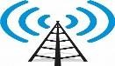

Base Station

LoRa

GSM

Battery

Microcontroller

Base station working Process